962v2.0 Software Instruction

1、Open the temperature data software, as shown in the following figure
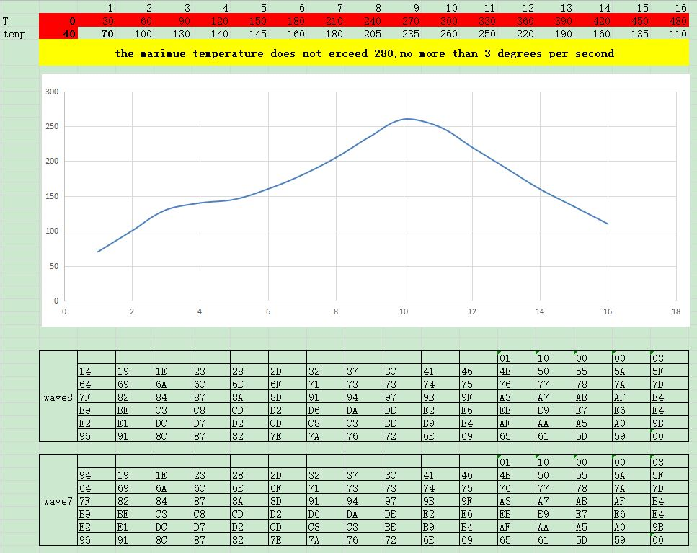
Select the data in Curve 7 or Curve 8 and copy it.
"T" corresponds to the heating time, (time marked in red is forbidden to modify).
"temp" Specifies the temperature in the specified time (the starting temperature in red is forbidden to modify).
Click on the unred temperature cell, modify the temperature,(Temperature increase not exceeding 3 degrees per second.) Click the left mouse button in the blank area or click the keyboard "Enter" key to refresh the data to observe the newly generated temperature curve. At the same time, the data in the two text areas down will be updated. Select all the data in the text area of the 7th or 8th curve to be set and copy.

2、Open the "Serial COM" software
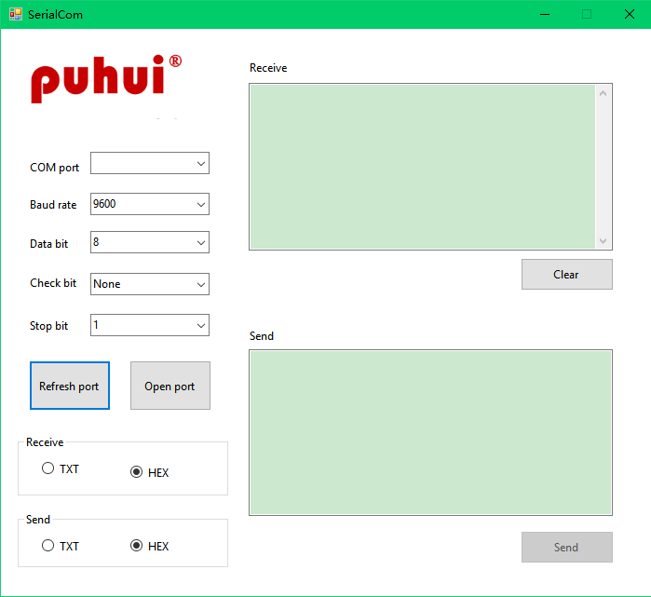
① Identify the port: If you do not know the port, you can first open the program, view the port list;connect the serial port line, click "Refresh Port", the new port in the port list is the required port;
② Set parameters: In addition to the port generally do not need to change;
③ Open the serial port: After the serial port is opened, all parameters cannot be adjusted. After the serial port is closed, you can modify the parameters again.
④ Data sending: Input the data into the sending area, click the "Send" button, and the message "Data has been sent" will appear, then the data has been sent;(The reflow oven gives a "beep" indicating successful data transmission).

